**Film adaptations and Austen Time**

A future that Jane Austen could not possibly have imagined awaited *Northanger Abbey*:  the filming of her novel.  There are two adaptions available from twenty years apart:  a 1987 BBC telefilm with a screenplay by Maggie Wadey and a 2007 ITV telefilm with a screenplay by Andrew Davies.[4](https://jasna.org/publications-2/persuasions-online/volume-40-no-1/greenfield-troost/#Note-4)  If the novel is, as we argue, about modernity and culture on the move, how can a film adaptation convey that?  The answer is simple:  it cannot.  Any film audience will be so aware of the split between its present world and Austen’s world, that it becomes difficult to portray on screen.  How can one show a modernity that is now two hundred years old?

|  |  |  |
| --- | --- | --- |
| GT4  *Northanger Abbey.  © 1987 BBC* |  | GT5  *Northanger Abbey.  © 2007 ITV* |

The films do not even try to do so.  Filmed period drama since the mid-1990s has instead worked in something that we have decided to call *Austen Time*, an amalgamation of period details that viewers instantly recognize as creating the “look” of the time period.  It results from the filmic homogenizing of about two decades in the early nineteenth century, and the blending obscures datable cultural trends such as varying hemlines on petticoats and styles of carriages.  Sometimes, even greater timespans merge with minimal ill effects.  Jennifer Ehle and Colin Firth spar to “Mr. Beveridge’s Maggot,” a dance from around 1700 that no Austen character would have recognized.  Keira Knightley shares screen time with Victorian statuary at Pemberley and four well-grown sequoias at Longbourn.[5](https://jasna.org/publications-2/persuasions-online/volume-40-no-1/greenfield-troost/#Note-5)  Soundtracks, dances, food, architecture, and clothing need only strike the audience as “period” or “Regency” to do their work.

After all, film makers are not doing historical re-enactment; they are creating art and entertainment.  Nor is historical reconstruction feasible.  A screenwriter or director who tries to capture the modernity of the world of *Northanger Abbey* has to overcome the problem that what is modern to Catherine is really old to the viewer.  Also, buildings and towns cannot be made to look as new as they would have to Austen’s characters:  they are now historic properties, so the willing suspension of disbelief must come into play.  Films operate by different rules, and Austen Time is sufficient for the purpose.

That makes filming *Northanger Abbey* a challenge.  Film is a visual medium, so it ends up focusing less on books and reading, language change, and things that matter a great deal in the novel in order to privilege image.  That results in an emphasis upon the gothic, which is eminently visual but largely important only in the second half of Austen’s novel.  For example, before Catherine Morland meets Isabella Thorpe in Bath, the only hints of the gothic in Austen’s novel come not in Catherine’s attitude but in narratorial comments about its absence:  a *lack* of robbers, tempests, and bad baronets to beset Catherine on the trip to Bath.  The narrator sets a standard for modern social realism in the novel.  Admittedly, some critics try to inject the gothic into the first half of the novel, seeing, for example, John Thorpe as a would-be gothic villain, but he is one only in “parody” (*NA*326 n12), and his “abduction” of Catherine is ultimately one with ironic quotation marks around it (Yee).  Kathy Gentile is amused by “John Thorpe’s bumptious declarations of masculine superiority” (79), but *bumptious* is the opposite of *threatening,* and serious threat is the essence of gothic.

**More gothic**

Both film adaptations, however, bring the gothic in quickly and give it distinctly non-bumptious treatment.  Each has Catherine reading the novels of Mrs. Radcliffe before she goes to Bath.  The 1987 BBC telefilm shows Catherine lolling in a tree reading what we are to assume is *The Mysteries of Udolpho* while indulging in erotic fantasies.  The 2007 ITV version gives Catherine Mrs. Radcliffe’s *The Romance of the Forest* to read and fantasize over.  By depicting Catherine’s gothic imaginings as a long-standing practice, the films make her later suspicions about General Tilney’s having murdered or imprisoned his wife dramatically consistent.  This is not the case in the novel:  Catherine tells Isabella that “‘new books do not fall in our way’” (35) at the Morland home.  Nor is she especially imaginative until she goes to Northanger Abbey.

The Bath sequences also allow for a filmic interpolation of the gothic.  The 1987 film gothicizes the characters with edgy costumes and make-up.  John Thorpe is often menacing. Isabella is a little vampiric, and even Henry a bit unnerving, with close-ups that bring him too close for comfort and few hints in his delivery that he is being witty and ironic.  Everyone looks surreal, even Catherine at times.  The 2007 version initially follows the novel by including a lot of Austen’s wit in the narrative voice-over about Catherine’s childhood, but it quickly moves to the gothic.  After her first ball, Catherine dreams that Henry Tilney is rescuing her from a masked villain who turns out to be John Thorpe—even though we know “it must be very improper that a young lady should dream of a gentleman before the gentleman is first known to have dreamt of her” (22).  To play up the creepy strain further, Thorpe utters—without a touch of bumptiousness—serious reservations about the Tilney clan.  He tells Catherine that “I’m not altogether happy to see you with the Tilneys.  The whole family has a terrible reputation. Something very strange about the mother’s death.”  We, as well as Catherine, are being primed to think of General Tilney as a gothic villain.  In contrast, Austen’s general has a perfectly fine reputation.  Isabella tells Catherine, “‘I know no harm of him; I do not suspect him of pride.  I believe he is a very gentleman-like man.  John thinks very well of him’” (132). The point in both films seems to be that Bath and its visitors are of a piece with a gothic abbey, which does help solve the difficulty of the novel’s seemingly bifurcated tone.

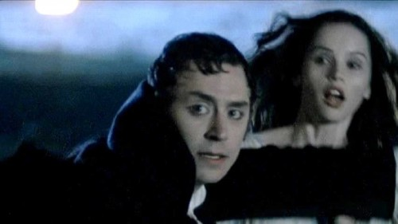

*Dream sequence.  © 2007 ITV*

Austen, however, has actually united the two halves of her novel by showing that getting and spending dominate modern life.  Shopping for material goods is central:  Bath is full of fashionable clothing, fabrics, and vehicles, and Northanger Abbey is not so different.  It is “an anti-Udolpho: bright and clean and hospitable and with every modern comfort and luxury” (Southam, “General” 59).  Mr. Tilney knows his muslins; and his father knows his up-to-date consumer goods, much to Catherine’s disappointment:

The [Abbey] furniture was in all the profusion and elegance of modern taste.  The fire-place, where she had expected the ample width and ponderous carving of former times, was contracted to a Rumford [invented in 1797], with slabs of plain though handsome marble, and ornaments over it of the prettiest English china.  The windows, to which she looked with peculiar dependence, from having heard the General talk of his preserving them in their Gothic form with reverential care, were yet less what her fancy had portrayed.  To be sure, the pointed arch was preserved—the form of them was Gothic—they might be even casements—but every pane was so large, so clear, so light!  To an imagination which had hoped for the smallest divisions, and the heaviest stone-work, for painted glass, dirt and cobwebs, the difference was very distressing.  (165–66)

No film adaptation picks up on the delightful comedy of Catherine’s disappointment with replacement windows, efficient heating, and elegant furniture since it works against the gothic mood the films develop.  Neither film shows the house tour, in which the General points out all the mod cons and updates:  pro-style kitchen range, modern “offices” for laundry and such, and the latest in gardens and greenhouses for his *au courant* passion for raising pineapples.[6](https://jasna.org/publications-2/persuasions-online/volume-40-no-1/greenfield-troost/#Note-6)  The gentle mockery of Catherine’s overactive imagination is confined in the films to the funny scene where she finds the laundry lists—though the 1987 film adaptation slips a cryptic letter of romantic assignation into the pile of paper, thereby undercutting Austen’s joke.  But modernity does not work with Austen Time.  The viewer will have trouble recognizing the extreme newness of a tea set or a fireplace design within the period context.  Therefore, even though Austen did the reverse, the films transform non-gothic things in Bath and at the abbey into gothic things.

The depiction of the late Mrs. Tilney’s bedroom is a prime example of this reversal of what the author intended.  In the novel, it is located in the new wing, the section built by the General’s father.  It is described as a large, well-proportioned apartment, [with a] handsome dimity bed, arranged as unoccupied with an housemaid’s care, a bright Bath stove, mahogany wardrobes and neatly-painted chairs, on which the warm beams of a western sun gaily poured through two sash windows!  Catherine had expected to have her feelings worked, and worked they were. Astonishment and doubt first seized them; and a shortly succeeding ray of common sense added some bitter emotions of shame.  (198–99)

The discovery of seeing a clean, cheery, impersonal, and modern room instantly jolts Catherine into realizing that her recently acquired imagination has run away from her.  Austen grants Catherine the intelligence to work this out for herself; she does not really need Henry’s lecture.  Hearing it, however, is the penance she must undergo for her folly, and it is a good reminder to the readers that they, too, live in a modern world, not a gothic novel.

The films, in contrast, play this scene quite seriously.  Both the 1987 and the 2007 films locate the bedroom in the oldest, most remote part of the Abbey, up well-worn stairs, down mysterious passages, through ancient doors.  In the 1987 film, the floors and doors creak, the room is full of old oak furniture, Elizabethan portraits and medieval candlesticks.  Mrs. Tilney’s personal effects are still present but covered with dust, as if the room had been hastily sealed immediately after her death.  The 2007 film adds shroud-like drapes and even more dust.  In both versions, there is nothing to give the game away:  each antique bedroom could easily have been a room for nefarious activities by a thoroughgoing gothic villain.  The films side with Catherine, supporting her fantasy instead of satirizing her, as Austen does.  Rather than *parody* the gothic, they *become* gothic.

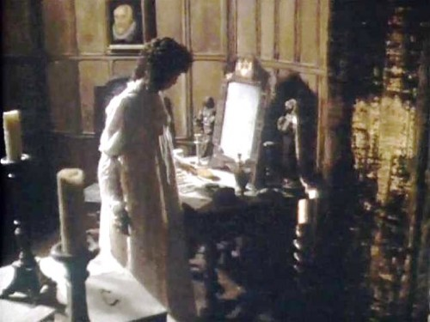

*Catherine explores Mrs. Tilney’s bedroom.  © 1987 BBC*

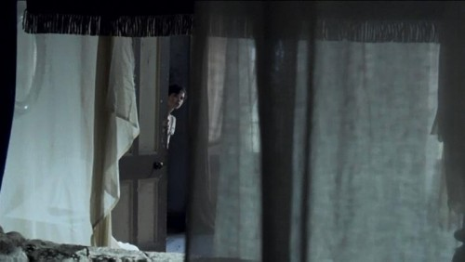

*Catherine explores Mrs. Tilney’s bedroom.  © 2007 ITV*

Break Graphic true to size

For Austen, however, the gothic is not the central issue in her novel.  The novel looks squarely at the present.  For Austen, what links the scenes at Bath to those at the Abbey is that both show a shallow, modern world full of petty concerns for money, social advancement, and lots of up-to-date possessions:  modern novels, showy gigs, fashionable clothing, trendy fruit, modern appliances, and the latest in Staffordshire porcelain tea sets: “this was quite an old set, purchased two years ago” (179), apologizes General Tilney, though actually bragging.  Admittedly, the world of *Northanger Abbey* has its own distresses, but they are modern ones and not in the same league as those in gothic novels.  As a result, the films do what Catherine Morland briefly does:  make the world more exciting than it is.

Undeniably, *Northanger Abbey* criticizes those who, in some senses, are too modern—concerned mainly with time and money, like General Tilney—but the satire also falls upon those like Catherine, who romanticize the past.  Henry’s rebuke to her when he finds her in his late mother’s bedroom brings the readers jolting back to the present: “‘Remember the country and the age in which we live . . . where roads and newspapers lay everything open’” (203).  Pity the modern viewers, though, who may feel returned from Catherine’s wild imaginings, but will not be returned to their own time, which was the intended effect of Henry Tilney’s “hey, look around you” moment that Austen carefully constructed.  After all, they are watching period drama and remain with Catherine in Austen Time, a romanticized past.  To date, the film adaptations of *Northanger Abbey* have proven not entirely satisfactory because they cannot capture the essence of Austen’s novel, which is an appreciation for modern life.  Period drama about the modern proves to be a contradiction in terms.